1. What happens when you type a URL into your browser?
   1. https://www.educative.io/blog/behind-the-screens-what-happens-when-you-type-a-url-in-a-browser
2. 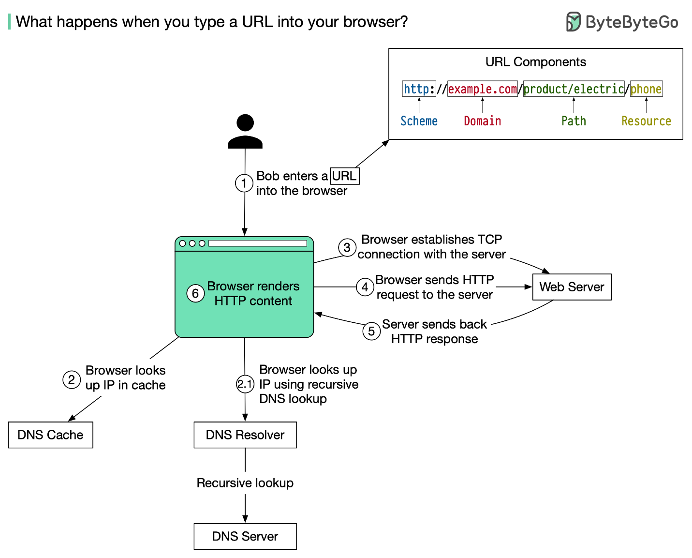
3. A **Uniform Resource Locator (URL)** is used to locate a resource, in our case, the website on a server. The requested resource can be a file of any kind, for example, an MP3 file, an image, or a C++ file.

The URL tells your browser two things:

* 1. Domain name(google.com/facebook.com)
  2. Path to resource/file

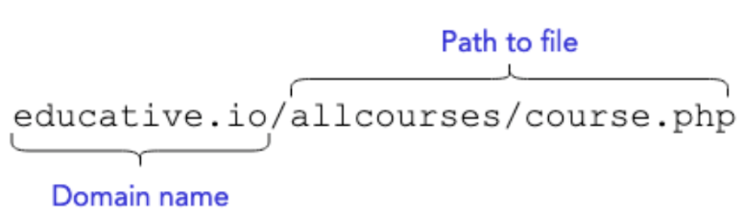

1. What is DNS?



To save computers searching the entire web each time a domain is entered, the browser checks more local DNS record stores. This is done in 3 steps:

1. The browser’s local cache is checked
2. The operating system’s cache is checked
3. The router is checked for the record.
4. Lastly, the query is sent to the Internet Service Provider (ISP) for it to check its cache.

DNS server hierarchy:

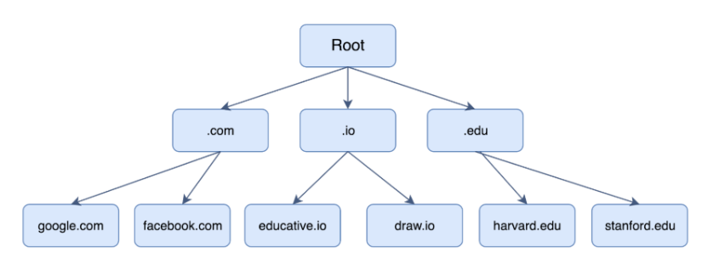

1. What is HTTP ?
2. **TCP works in the Transport layer while HTTP works in Application layer of TCP/IP model. This just means that HTTP works on top of TCP. TCP is in charge of setting up a reliable connection between two machines and HTTP uses this connection to transfer data between the server and the client. HTTP is used for transferring data while TCP oversees setting up a connection which should be used by HTTP in the communication process. Without TCP, HTTP cannot function (to be crisp).**
3. **Component files:**

A website is made up of many different files, which are like the different parts of the goods you buy from the shop. These files come in two main types:

* **Code files**: Websites are built primarily from HTML, CSS, and JavaScript, though you'll meet other technologies a bit later.
* **Assets**: This is a collective name for all the other stuff that makes up a website, such as images, music, video, Word documents, and PDFs.

1. Order in which component files are parsed –

https://developer.mozilla.org/en-US/docs/Learn/Getting_started_with_the_web/How_the_Web_works

1. What are render blocking resources?  
   https://blog.logrocket.com/9-tricks-eliminate-render-blocking-resources/